**Software Engineering Assignment**

**Module 1**

**SE – Overview of IT Industry**

1. **What is software ? what is software engineering ?**

**Software :**

* Software is the digital component of computer system.
* Software is set of instruction & data.
* Software is the program that operate the computer or execute specific tasks.

**Software engineering :**

* This is the structured approach used to build and maintain software product.
* There are basic principal to make high quality software
* Analysis
* Design
* Development
* Testing
* Maintenance

1. **Explain types of software**

There is two types of software :

1. System software :

* These are for managing hardware resources and providing services for application software
* This include the operating system( windows , macOS ) , drivers

1. Application software :

* This is the programs that designed to perform specific task
* It includes the wab browsers , video game

1. **What is SDLC ? explain each phase of SDLC**

**SDLC :**

* SDLC is Software Development Life Cycle
* This is the structured process used by developers team to develop high quality software.
* By following the SDLC the developers team can better plan and control the software

Their are the deferent phases of SDLC

* Planning :
* it involves the involves information to understand the project objectives , scope , and feasibility,
* the is define the problem then software is solve the problem or not.
* Planning is the understanding the project’s scope, budget, timeline, and goals.
* Analysis :
* In this phase the developer team is work on requirement of software in bases of the clients
* Analysis phases is the phases where the developer team is analyse the problem of clients and ensure the software are solve the business need.

* Design :
* In this phases the system architecture and design are planned base on the requirements.
* In this phases create the blueprint of software.
* Design the system architecture , defining hardware , software , user interface , database .
* Development :
* In this phase the developers are develop the software.
* Develop the software by following the design documents and using the selected programming languages.
* Testing :
* When the software is developed then the tested to ensure it functions as expected and as the requirements.
* By the testing of software they can find the bugs and issues so can resolved and fixed before use.
* Maintenance :
* This phase is for the maintained the software.
* This phase involves the regular update , bug fixes , the software iswork continues as over time.
* Adding new features based on user feedback or changing requirements.

1. **What is DFD ? create a DFD on Flipkart**

**DFD :**

* DFD is Data Flow Diagram.
* DFD is the graphical representation of the system. It shows how input data transformed into output data through the processes.
* It useful for designing and analyzing the system

**DFD on Flipkart :**

**Level 0 :**

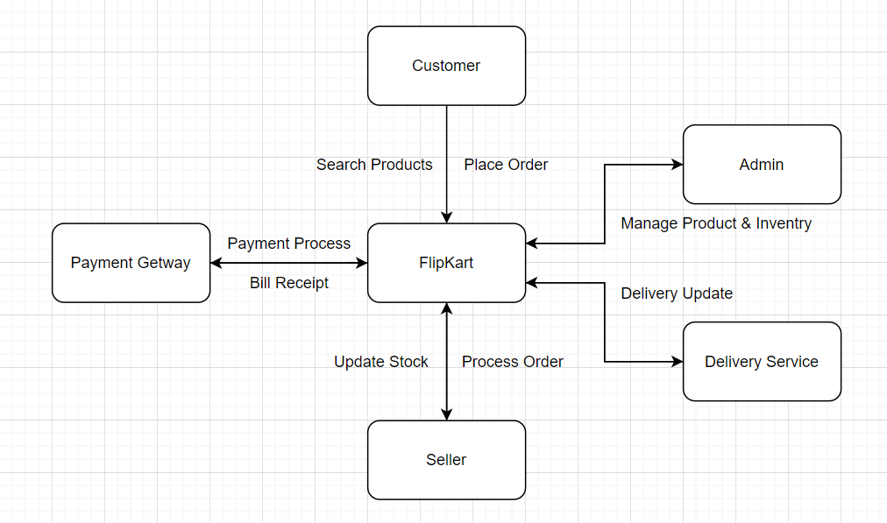

**Level 1 :**

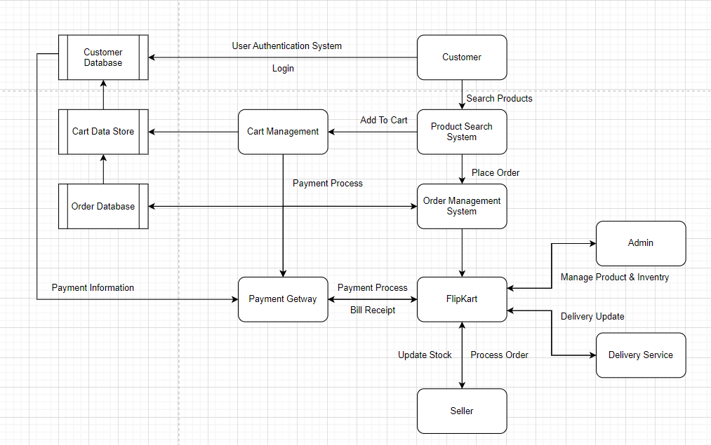

1. **What is flowchart ? create a flowchart to make addition of Tow numbers**

Flowchart :

* Flowchart is graphical representation of algorithm.
* It use symbols to describe the different types of action.
* Like, Ovel : for start & end process

Rectangle : represents the process

Parallelogram : for input & output

Diamond : for decision or condition making situation

Arrow : to show the direction

Flowchart to make Addition of Two Number

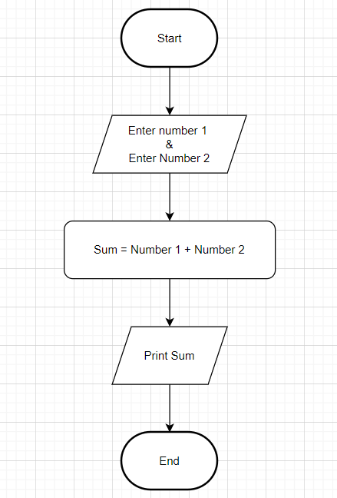

1. **What is use case diagram ? create a use-case on bill payment on paytm.**

Use case diagram :

* Use case diagram is digital representation of system process between actors and system.
* In this diagram use actor symbol to represent the user or external entity

Use case on Bill Payment on paytm

